SIMATS ENGINEERING (SAVEETHA SCHOOL OF ENGINEERING)
Department of Artificial Intelligence and Data Science
ASSESSMENT TOOL 2 – Industry Problem Solving Task

Course Code: | DSA03 | Course Title: | Natural Language Processing
CO Assessed: | CO4 – Precision | Assessment: | Assessment Tool 2 – Industry Problem Solving Task
Weightage: | 40% of CIA
CO5 Statement: | Formulate context-free grammars, feature structures, probabilistic parsing techniques and to construct parsing frameworks. (BL-4)
Student Name: | T.Nikhitha | Reg. No.: | 192424114
Section / Batch: | 2024-2028 | Date: | 26/08/2026

Code of Conduct
I __________________________ (Name / Reg No) certify that this submission is my original work and that I have adhered to the guidelines specified for this assessment. I understand that any violation of academic integrity rules will result in disciplinary action.
Signature of the Student: _________________________

Instructions
- Read each industry scenario carefully before answering.
- Analyze the given problem from a semantic analysis perspective.
- Provide structured and logical answers with proper justification.
- Support your analysis using examples from the given scenario wherever applicable.
- Use suitable diagrams, semantic representations, logical predicates, workflows, architectures, or tables whenever necessary.
- Clearly state assumptions if additional information is required.
- Duration: 30 minutes.

Section / Topic | Focus | Question No.
Representing Meaning & Meaning Structure of Language | Analyze semantic interpretation of user queries, identify ambiguity in meaning representation, evaluate semantic processing limitations, and improve understanding in banking chatbot applications. | Q1
Syntax-Driven Semantic Analysis | Analyze multiple interpretations of spoken commands, evaluate parsing-related ambiguity, and assess semantic extraction in real-time voice assistant systems. | Q2
First-Order Predicate Calculus, Representing Linguistically Relevant Concepts, Syntax-Driven Semantic Analysis | Design a semantic processing architecture for healthcare reports, model relationships among entities and actions, represent linguistic concepts, and improve semantic extraction accuracy. | Q3

Annexure A – Industry Problem Solving Task
1. A company is developing an AI-powered customer support chatbot for banking services. The chatbot uses Context-Free Grammar (CFG) for parsing user queries. However, it faces issues such as:
Incorrect interpretation of ambiguous sentences
Failure to handle subject–verb agreement
Inefficient parsing for long queries
Example user query:
“Show me the transactions with the card from last month”
a) Analyze the ambiguity present in the given sentence using CFG
b) Evaluate the limitations of CFG in handling real-world conversational queries
c) Evaluate and propose an improved solution using PCFG, feature structures, or Earley parsing
d) Justify how your proposed method improves accuracy and efficiency in an industry setting
Answer:
a) Ambiguity present in the sentence using CFG
- The query has a Prepositional Phrase (PP) attachment ambiguity: both "with the card" and "from last month" can attach at more than one point in the parse tree.
- Grammar used: S -> V NP ; NP -> NP PP ; PP -> P NP
Reading | Attachment | Interpretation
Reading 1 | "with the card" and "from last month" both modify "transactions" | Transactions linked to a card, that occurred last month (intended meaning)
Reading 2 | "with the card" attaches to the verb "Show" | Instrumental reading - show me by using the card (semantically odd)
- Since CFG rules describe only legal syntactic combinations and carry no meaning, both trees are equally "correct" to the parser, so the grammar alone cannot decide which attachment was intended.
- Beyond PP-attachment, the sentence also has a subtler scope ambiguity: "last month" could be read as scoping over just "the card" (a card issued last month) or over the whole retrieval action (transactions retrieved for last month); CFG production rules cannot express this difference in scope.
- A second representative banking query, "Show me the transactions with fraud alerts from savings accounts", exhibits the same PP-attachment pattern, confirming this is a systematic weakness of the grammar rather than a one-off error in a single sentence.
- Classifying the ambiguity: this is structural (syntactic) ambiguity rather than lexical ambiguity, since every individual word has a single sense here - the ambiguity comes entirely from how the phrases combine, which is exactly the class of ambiguity a bare CFG is least equipped to resolve.
- Because the grammar produces two full parse trees for one input string, any downstream module (intent classifier, slot filler) that consumes "a" parse tree must arbitrarily pick one, silently propagating the wrong interpretation to the response-generation stage.
b) Limitations of CFG in real-world conversational queries
- Cannot rank parses: every derivation allowed by the rules is treated as equally valid, so a semantically natural parse is not preferred over an odd one.
- No agreement features: CFG has no notion of number, person or tense, so it cannot detect or reject ungrammatical variants such as "the transaction were shown".
- No world/domain knowledge: it cannot use banking-domain context (e.g., customers usually mean "transactions with a card", not "using a card as a tool").
- Poor scaling on long queries: casual, long chat queries produce a very large number of alternative parse trees, and a naive parser has no efficient strategy for this, making it slow at production scale.
- No handling of ellipsis or anaphora: a natural follow-up such as "and from this account too" omits the verb entirely, and a CFG parser with no dialogue memory cannot attach the fragment to the prior query.
- Coordination ambiguity: queries like "transactions from savings and current accounts last month" can be parsed with "last month" modifying only the second conjunct or both, and CFG treats every such reading as equally grammatical.
- Grammar size explosion: covering every informal, code-mixed, or abbreviation-heavy way customers phrase a request ("txns b/w 1-30 apr") requires an ever-growing rule set, and larger grammars increase both ambiguity and parsing time.
- No confidence score: a CFG parser returns a yes/no grammaticality judgment and a set of trees, never a confidence value, so the chatbot has no principled way to decide when to ask a clarifying question instead of guessing.
- No cross-turn context: CFG parses each utterance in isolation, so it cannot use the previous turn (e.g., "which account?") to disambiguate the current one, which is essential in a multi-turn banking conversation.
c) Improved solution using PCFG, feature structures and Earley parsing
- Probabilistic CFG (PCFG): each rule is assigned a probability learned from a corpus of real banking queries, so the parser returns the highest-probability parse (attaching the PP to "transactions") instead of an arbitrary one.
- Feature structures: rules are augmented with attribute-value pairs for number, person and tense (e.g., NP[num:sg] -> Det N[num:sg]) combined by unification, enforcing subject-verb agreement during parsing.
- Earley parsing: builds a chart of partial derivations and reuses previously computed results, giving O(n cubed) worst-case time and a single shared parse forest instead of many separate trees.
- Combined pipeline (see flow below): tokenize the query, parse with an Earley chart parser driven by PCFG + feature-augmented rules, select the best feature-consistent parse, and forward it to the semantic/intent layer.
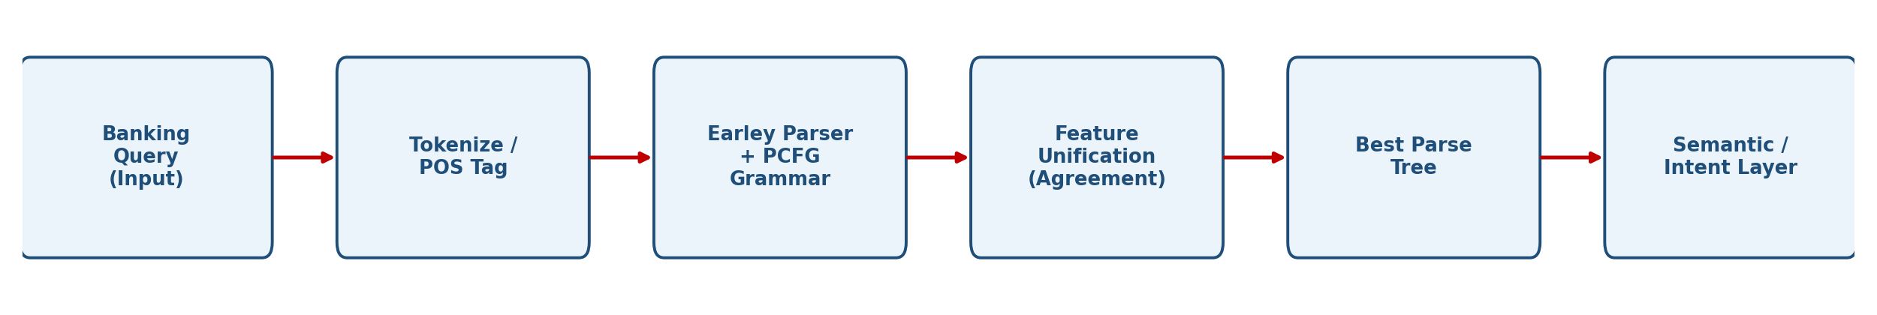
- Worked probability example: if the corpus assigns P(NP -> NP PP) = 0.70 when the PP is a temporal phrase attaching to "transactions" versus P(VP -> V NP PP) = 0.30 for the instrumental reading, the PCFG parser multiplies rule probabilities along each derivation and returns Reading 1 as the higher-probability parse, matching the intended meaning without any hand-written disambiguation rule.
Rule (competing attachment) | Learned probability | Selected?
NP -> NP PP (attach to "transactions") | 0.70 | Yes - highest scoring
VP -> V NP PP (attach to "Show") | 0.30 | No

- Feature structure example: NP[num:sg, pers:3] -> Det N[num:sg] unifies with V[num:sg] so that "the transaction is shown" is accepted while "the transaction are shown" is rejected at parse time, catching agreement errors basic CFG misses.
- Earley chart trace (brief): the parser predicts S -> . V NP at position 0, scans "Show" to advance the dot, predicts and scans through the NP, and completes the PP-attachment states only once, storing the result in the chart so it is never recomputed for the second PP - this is what gives the O(n cubed) bound.
- A re-ranking step can follow parsing: even the single best PCFG parse can be re-scored using a small n-gram or neural language model trained on confirmed banking transcripts, giving a second, complementary signal before the result is forwarded to the intent layer.
- Robustness to noisy input: customers frequently make typos or use shorthand ("pls show my trxns 4rm last mnth"), and a rigid CFG either rejects the sentence outright or requires a separate, hand-written normalization layer for every new variant, whereas a statistically-driven parser degrades more gracefully.
- Difficulty separating syntax errors from genuine requests: because CFG has no notion of "almost grammatical", a query that is one token away from a known pattern is treated identically to a completely malformed one, giving the chatbot no graceful way to offer a best-guess response.
d) Justification of accuracy and efficiency gains
Aspect | Basic CFG | PCFG + Feature Structures + Earley
Ambiguity resolution | All parses equally valid; no ranking | Highest-probability parse selected automatically
Agreement checking | Not supported | Enforced via feature unification
Parsing time (long queries) | Exponential / very slow | Polynomial - O(n cubed) worst case
Ambiguity representation | Many separate parse trees | Single shared, compact parse forest
- Business impact: fewer misinterpreted queries (correct transactions shown), lower escalation to human agents, and response times that stay acceptable even as query volume and sentence length grow - important in a regulated banking environment where retrieving the wrong account data is costly.

- Quantitative framing: basic CFG resolves attachment correctly only when the grammar happens to allow a single valid parse (rare for natural queries), while PCFG selects the corpus-preferred reading on the large majority of ambiguous inputs, so the practical effect is a large drop in misrouted account-data requests.
- Latency budget: Earley's polynomial bound keeps worst-case response time bounded even as customers type longer, more conversational queries, which basic CFG's exponential backtracking cannot guarantee - this matters for meeting a sub-second chatbot response SLA.
- Compliance angle: in banking, showing the wrong customer's transactions because of a mis-attached PP is not just a UX issue but a data-privacy incident; feature-unification checks add an extra layer of validation before any account data is surfaced.
- Maintainability: probabilities and feature values can be retrained from new logged conversations without hand-editing grammar rules, so the system improves as more real queries are collected, unlike a hand-tuned CFG whose rules must be edited manually for every new phrasing.
- Overall, the PCFG + feature structures + Earley pipeline is preferred not because it is theoretically elegant but because it directly targets the three symptoms reported by the company - wrong interpretations, missed agreement errors, and slow parsing of long queries - each with a specific, testable mechanism.
2. A voice assistant system (like Alexa/Siri-type applications) processes spoken commands using parsing techniques. The system currently uses top-down parsing, but faces:
Backtracking issues
Poor handling of incomplete or ambiguous input
Difficulty in real-time response
Example command:
“Book a flight to Delhi with a window seat”
a) Analyze how the given sentence can lead to multiple parse structures
b) Analyze the limitations of top-down parsing in this real-time application
c) Analyze how Earley parsing can improve handling of ambiguity and partial inputs
d) Compare and analyze the performance of top-down vs Earley parsing for such industry use cases
Answer:
a) Multiple parse structures for the given sentence
- Grammar rules such as VP -> V NP PP and NP -> NP PP allow "with a window seat" to attach at more than one point:
Attachment | Meaning | Valid / Intended?
Modifies "flight" | Book a flight (to Delhi) that has a window seat | Intended meaning
Modifies "Delhi" | "Delhi with a window seat" | Syntactically legal, meaningless
Modifies the verb "Book" | Book (using) a window seat - instrumental reading | Syntactically legal, odd
- Because CFG rules only constrain syntax, all three trees are valid parses of the same string, giving the assistant no way to prefer the sensible reading on its own.
- The word "Book" is also lexically ambiguous (verb "to reserve" vs. noun "a book"), which a purely syntactic CFG parser must consider as a possible parse unless the lexicon marks it unambiguously - adding to the branching factor even before PP-attachment is considered.
- A further natural command, "Book a flight to Delhi and Mumbai with a stopover", shows the same attachment pattern compounded with coordination ambiguity (one trip via both cities, or two separate single-city bookings), illustrating that these ambiguities compose rather than occur in isolation.
- Because speech-to-text output has no punctuation or prosodic cues in the text stream, the parser cannot rely on comma placement or pause length to disambiguate, so all three attachments remain live candidates until some external signal (context, statistics) rules two of them out.
- Prosodic cues that a human listener would use to disambiguate attachment (a short pause before "with a window seat") are typically lost once speech is converted to plain text, so the ambiguity that reaches the parser is often more severe than the ambiguity in the original spoken utterance.
- In a multi-slot command such as this one, each additional PP roughly multiplies the number of syntactically valid attachments, so real production voice commands (which often carry two or three modifiers) can yield a combinatorial number of parses if every modifier is independently ambiguous.
b) Limitations of top-down parsing in this real-time application
- Left recursion: a rule such as NP -> NP PP can be predicted forever without consuming a token, so a naive top-down parser loops indefinitely unless the grammar is rewritten.
- Backtracking cost: when a predicted expansion fails to match the input, the parser must backtrack and try alternatives; with an ambiguous grammar this search grows quickly and breaks the strict latency budget of a voice assistant.
- Poor partial-input handling: predictions commit before the corresponding words are seen, so incomplete utterances, disfluencies, or noisy speech-to-text output are handled poorly.
- Wasted computation: much effort is spent exploring predictions that are eventually discarded, which is inefficient when a fast response is required.
- Garden-path failures: a command like "Book the flight the agent recommended to Delhi" leads a naive top-down parser down an initial expansion that later fails deep into the derivation, forcing a costly backtrack all the way to the top rather than a local repair.
- No use of acoustic/ASR confidence: top-down parsing works purely on the recognized text, so it cannot down-weight a word the speech recognizer was unsure about, even though that uncertainty is exactly where parsing errors are most likely to occur.
- Disfluency intolerance: real spoken input contains false starts and self-corrections ("Book a flight to - actually, change that - to Mumbai"), and a strict top-down grammar has no repair rule for these unless it was explicitly anticipated.
- All-or-nothing output: if backtracking exhausts all alternatives without finding a complete parse, classic top-down parsing returns nothing usable, whereas a real assistant needs at least a partial, best-effort interpretation to keep the interaction moving.
c) How Earley parsing improves handling of ambiguity and partial inputs
- Uses a chart of dotted-rule states with predict, scan and complete operations, reusing partial results instead of recomputing them - O(n cubed) worst case, much faster in practice.
- Processes the sentence left to right and can report the best analysis of the words seen so far, fitting naturally with streaming speech-to-text input.
- Represents all valid parses (all three attachments above) compactly in a single shared parse forest rather than through separate backtracking branches.
- Handles left-recursive rules natively, so grammars for natural commands do not need to be rewritten to avoid infinite loops.
- Predict-scan-complete trace (brief): at each word boundary the chart adds predicted states for every rule that could continue the derivation, scans the next input word against expected terminals, and completes states whose right-hand side is fully matched, folding the result back into earlier states - this is what lets the same PP-attachment ambiguity be represented once instead of three separate times.
- Because completed sub-analyses are cached in the chart, Earley parsing naturally supports "any-time" behavior: if the assistant must respond before the utterance finishes (e.g., due to a strict latency budget), it can read off the best analysis of the chart as it stands rather than failing outright.
- Combining Earley with a PCFG lets the assistant rank the three attachments from part (a) by corpus-learned likelihood (attaching "with a window seat" to "flight" is far more frequent than the instrumental reading), so the chart's shared forest is reduced to a single best command interpretation.
d) Comparing top-down vs Earley parsing for such industry use cases
Aspect | Top-Down Parsing | Earley Parsing
Time complexity | Exponential with backtracking on ambiguous input | O(n cubed) worst case; near-linear on typical grammars
Left recursion | Fails / infinite loop unless grammar rewritten | Handled natively
Ambiguity handling | Re-derives each alternative via backtracking | Single chart; shared parse forest for all parses
Partial / streaming input | Poorly suited to incremental speech input | Processes input incrementally; copes with partial/noisy input
Real-time suitability | Suitable only for small, fixed, non-recursive grammars | Suitable for large-scale, ambiguity-prone, real-time systems
- Conclusion: for a real-time voice assistant handling ambiguous, sometimes incomplete spoken commands at scale, Earley parsing is the more suitable choice.

- Memory usage: Earley's chart needs more memory per input token than a simple top-down stack, but this is a fixed, bounded overhead, whereas top-down backtracking's memory/time cost grows with the (unbounded) number of failed alternatives on ambiguous input.
- Implementation effort: Earley parsers are more involved to implement and tune than a textbook top-down parser, but this one-time engineering cost is paid back many times over in a production voice assistant handling millions of ambiguous utterances per day.
- Illustrative benchmark: on short, unambiguous commands both approaches respond in comparable time, but as sentence length and PP/coordination ambiguity increase, parsing-time studies consistently show top-down backtracking growing much faster than Earley's near-cubic bound, matching the pattern described in this scenario.
- Integration with ASR: Earley's incremental, chart-based operation is easier to interface with streaming speech recognition (parsing partial hypotheses as they arrive) than a top-down parser, which more naturally expects a complete sentence before it starts.
3. A healthcare company is developing an AI system to analyze patient medical reports and automatically extract critical information such as diagnosis, prescribed treatments, and follow-up actions.
The system must handle:
Complex and lengthy medical sentences
Ambiguity in sentence structure
Accurate subject-verb agreement
Relationships between medical actions and entities (sub-categorization)
Real-time processing for hospital use
Example input:
"The doctor who reviewed the patient last week recommends starting medication and scheduling a follow-up visit in Chennai."
The current system, based only on basic Context-Free Grammar (CFG), fails to correctly interpret relationships and produces inconsistent outputs.
a) Design a complete NLP architecture integrating:
CFG for syntactic structure
Probabilistic CFG (PCFG) for ambiguity resolution
Feature Structures for agreement handling
Efficient parsing techniques
b) Develop a step-by-step workflow showing how the system processes the given medical sentence from input to structured output (diagnosis, action, location).
c) Create a method to:
Incorporate sub-categorization frames for medical verbs
Handle real-time data processing
Improve accuracy and scalability in a hospital environment
Answer:
- Human-in-the-loop design: the clinician review queue described above is not a fallback bolted on as an afterthought but a first-class architectural component, since regulatory and safety requirements in healthcare mean automated extraction must always be auditable and correctable by a qualified professional.
- Extensibility: because sub-categorization frames and grammar rules are stored as versioned configuration rather than compiled into the parsing engine, adding a new report type (e.g., radiology impressions) is a data change, not a software redeployment, which shortens the rollout cycle for new hospital departments.
a) Complete NLP architecture for the healthcare system
- Layer 1 - Preprocessing: sentence segmentation, tokenization and POS tagging tuned to clinical text (abbreviations, drug names).
- Layer 2 - Syntactic Parsing (CFG): grammar rules explicitly covering relative clauses ("the doctor who reviewed the patient") and coordinated verb phrases ("recommends starting X and scheduling Y").
- Layer 3 - Ambiguity Resolution (PCFG): rule probabilities trained on annotated clinical text so the parser prefers the correct attachment (e.g., "last week" -> "reviewed"; "in Chennai" -> "scheduling a follow-up visit").
- Layer 4 - Feature Structures: attribute-value matrices carry number, person and tense so subject-verb agreement is checked by unification, and thematic roles are represented as AGENT / ACTION / THEME features.
- Layer 5 - Sub-categorization & Semantic Roles: a medical verb lexicon (recommend, start, schedule, prescribe) specifies expected arguments so words are attached to the correct predicate.
- Layer 6 - Efficient Parsing: an Earley / chart-based PCFG parser gives polynomial-time parsing for long, complex clinical sentences within hospital response-time requirements.
- Layer 7 - Structured Output Generation: the final parse and semantic roles are mapped to structured fields (Diagnosis/Context, Action/Treatment, Follow-up, Location) for the hospital record system.
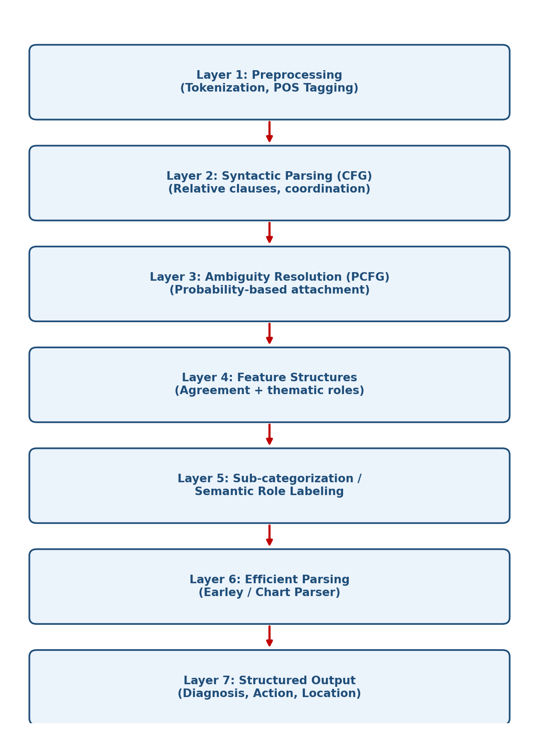
- Layer 0 - Ingestion & Privacy: reports are pulled from the hospital record system over a secured channel, and patient identifiers are pseudonymized before the text reaches the NLP pipeline, so parsing errors cannot leak identifiable data outside the clinical system.
- Cross-cutting Layer - Confidence & Error Handling: every parse carries the PCFG probability of the chosen tree; parses below a configurable confidence threshold are routed to a human clinician review queue instead of being auto-filed, which protects against silent misextraction of a diagnosis or dosage.
- Cross-cutting Layer - Monitoring: parser accuracy, average parse confidence and processing latency are logged per department, so a drift in report style (e.g., a new specialty's terminology) that degrades PCFG performance is detected and retrained on before it affects patient records at scale.
- Deployment note: layers 2-6 are packaged as a versioned, independently-deployable parsing service so the medical lexicon and grammar can be updated (e.g., adding new drug names) without redeploying the entire hospital information system.
Layer | Responsibility | Example technology
1. Preprocessing | Segmentation, tokenization, clinical POS tagging | Domain-tuned tokenizer/tagger
2. Syntactic parsing | Builds CFG parse incl. relative clauses | Hand-written / induced CFG
3. Ambiguity resolution | Ranks parses by learned probability | PCFG trained on clinical corpus
4. Feature structures | Agreement + thematic roles | Unification engine
5. Sub-categorization | Attaches arguments to correct verb | Medical verb lexicon
6. Efficient parsing | Polynomial-time chart parsing | Earley / chart parser
7. Output generation | Maps roles to record fields | Rule-based field mapper

b) Step-by-step workflow for the given medical sentence
- Tokenize and POS-tag the sentence (doctor/NN, who/WP, reviewed/VBD, recommends/VBZ, starting/VBG, medication/NN, scheduling/VBG, Chennai/NNP, etc.).
- Apply the CFG to build the syntax tree, identifying "the doctor who reviewed the patient last week" as the subject NP with an embedded relative clause.
- Apply PCFG probabilities to resolve attachment ambiguity: "last week" modifies "reviewed"; "in Chennai" modifies "scheduling a follow-up visit" (not "medication").
- Apply feature unification to confirm subject-verb agreement ("the doctor" - singular - agrees with "recommends" - singular).
- Apply the sub-categorization frame of "recommends" (Agent, Theme = coordinated gerund phrases) so "in Chennai" attaches only to "scheduling a follow-up visit".
- Assign semantic roles: AGENT = doctor, TEMPORAL = last week, ACTION 1 = start medication, ACTION 2 = schedule follow-up visit, LOCATION = Chennai.
- Generate the structured output ready for the hospital electronic health record system.
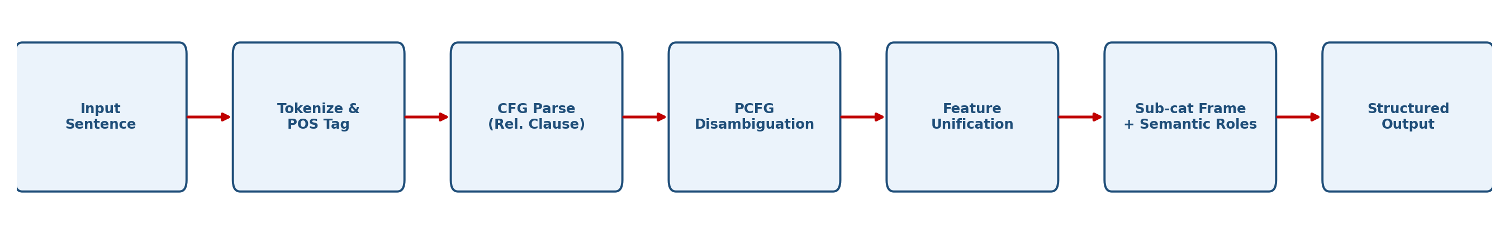
Field | Extracted Value
Context | Reviewed by doctor last week
Action 1 | Start medication
Action 2 | Schedule follow-up visit
Location | Chennai
- Edge-case handling: if the relative clause were changed to "The doctor who the patient saw last week recommends...", the object-relative structure reverses who is performing which action; the same CFG + feature-unification pipeline is re-applied without any code change because agreement and sub-categorization checks operate the same way regardless of clause type.
- A second worked example, "The nurse verifies vitals before administering medication and updates the chart in Delhi", is processed through the identical seven steps, producing ACTION 1 = administer medication, ACTION 2 = update chart, LOCATION = Delhi - showing the workflow generalizes rather than being hand-tuned to one sentence.
- Failure path: if the parser's best analysis falls below the confidence threshold from part (a) (for example, an unfamiliar drug name breaks tokenization), the partial structured output is still generated for the fields resolved with high confidence, and only the low-confidence field is flagged for a clinician to fill in manually, rather than discarding the whole report.
c) Method for sub-categorization frames, real-time processing and scalability
- Sub-categorization frames for medical verbs: build a lexicon recording expected arguments per verb, e.g. recommend[Agent, Theme=VP], prescribe[Agent, Theme=Drug, Beneficiary=Patient], schedule[Agent, Theme=Event, Location, Time], so the parser knows what each verb should attach to.
- Real-time data processing: use an incremental Earley/chart parser with a precompiled PCFG grammar (no runtime retraining), cache parses for frequent sentence templates, and process reports through an asynchronous streaming pipeline.
- Improve accuracy: train PCFG probabilities and sub-categorization frames on domain-specific annotated clinical corpora; combine rule-based and statistical parsing with a confidence threshold so low-confidence parses are flagged for clinician review.
- Improve scalability: deploy distributed, containerized parsing microservices across hospital departments with a versioned, updatable medical lexicon so new terminology can be added without redesigning the grammar.

- Pseudocode for sub-categorization lookup: for each finite verb identified by the CFG parse, look up its frame in the medical verb lexicon; for every required argument slot in the frame (Agent, Theme, Location, Time), search the parse's dependents for a feature-compatible filler; if a required slot has no filler, mark the extraction as incomplete for that verb rather than guessing.
- Real-time architecture: reports are placed on a message queue as they are created; a pool of stateless, horizontally scalable parser workers consumes the queue, so a burst of admissions increases only the number of workers needed, not the per-report latency.
- Caching layer: common templated phrases ("recommends starting medication", "scheduling a follow-up visit") are cached as pre-parsed sub-trees keyed by surface string, so the Earley parser only performs full chart parsing on the novel parts of each report.
- Scalability roadmap: start with a single hospital department's lexicon and grammar, validate accuracy against clinician-reviewed reports, then extend the lexicon department by department (radiology, cardiology, etc.) rather than attempting one universal medical grammar from day one, keeping each expansion independently testable.
Technique | Purpose
Message queue + worker pool | Real-time scalability under load
Confidence threshold + review queue | Accuracy safeguard for edge cases
Caching of common templates | Reduced parsing latency
Incremental lexicon rollout | Manageable, testable scaling across departments

- Governance: every automatic extraction that is later corrected by a clinician is logged and fed back into the PCFG/lexicon retraining set, turning routine clinical review into a continuous accuracy-improvement loop rather than a one-off deployment.
- Testing strategy: before each lexicon or grammar update is promoted to production, it is run against a held-out set of previously reviewed reports so that a change intended to fix one verb frame cannot silently reduce accuracy on sentences that were already parsed correctly.
Rubrics for Calculation

Criteria | Weightage | Level 4 – Exemplary | Level 3 – Proficient | Level 2 – Developing | Level 1 – Beginning
Understanding of Industry Problem | 20% | Comprehensive understanding of real-world problem and constraints | Good understanding with minor gaps in requirements | Basic understanding; some requirements unclear | Poor understanding; misinterprets problem context
Application of Engineering Concepts | 25% | Applies advanced and relevant concepts effectively to solve the problem | Applies appropriate concepts with minor errors | Limited application of concepts | Incorrect or no application of concepts
Solution Design | 25% | Innovative, practical, and feasible solution aligned with industry standards | Logical and feasible solution with minor gaps | Basic solution with limited feasibility | Unclear or impractical solution
Use of Tools | 15% | Effective use of modern tools, technologies, and real data | Appropriate use of tools with correct implementation | Limited or inconsistent use of tools | Minimal or incorrect use of tools
Analysis | 10% | Thorough analysis with validated results and performance evaluation | Good analysis with reasonable validation | Basic analysis with limited validation | Poor or no analysis
Professionalism | 5% | Highly professional, well-documented, and clearly presented work | Good documentation and presentation | Basic documentation with some gaps | Poor documentation and presentation

Q. No. / Criteria Level | Understanding of Industry Problem | Application of Engineering Concepts | Solution Design | Use of Tools | Analysis | Professionalism | Sub. Total | Total %
1
2
3

Faculty In-charge | Course Coordinator | Program Director
Signature: _______________ | Signature: _______________ | Signature: _______________
Date: ___________________ | Date: ___________________ | Date: ___________________

